**Code:**

1. **index.html**

<!doctype html>

<html lang="en">

<head>

<meta charset="utf-8">

<meta name="viewport" content=

"width=device-width, initial-scale=1">

<title>Suraj savji</title>

<link rel="stylesheet" href=

"https://code.jquery.com/mobile/1.5.0-alpha.1/jquery.mobile-1.5.0-alpha.1.min.css">

<script src=

"https://code.jquery.com/jquery-3.2.1.min.js">

</script>

<script src=

"https://code.jquery.com/mobile/1.5.0-alpha.1/jquery.mobile-1.5.0-alpha.1.min.js">

</script>

</head>

<body>

<center>

<div data-role="page">

<h1 style="color:#6060a3;">

My Portfolio

</h1>

<div data-role="header" id="GFG">

<div role="main" class="ui-content">

Name: Suraj Savji</br>

</br>

Roll No: TEITB81</br>

</br>

<a href="https://savjisuraj4.netlify.app/">https://savjisuraj4.netlify.app/</a>

</div>

</div>

</div>

</center>

</body>

</html>

**OUTPUT:**

1. **Desktop View**

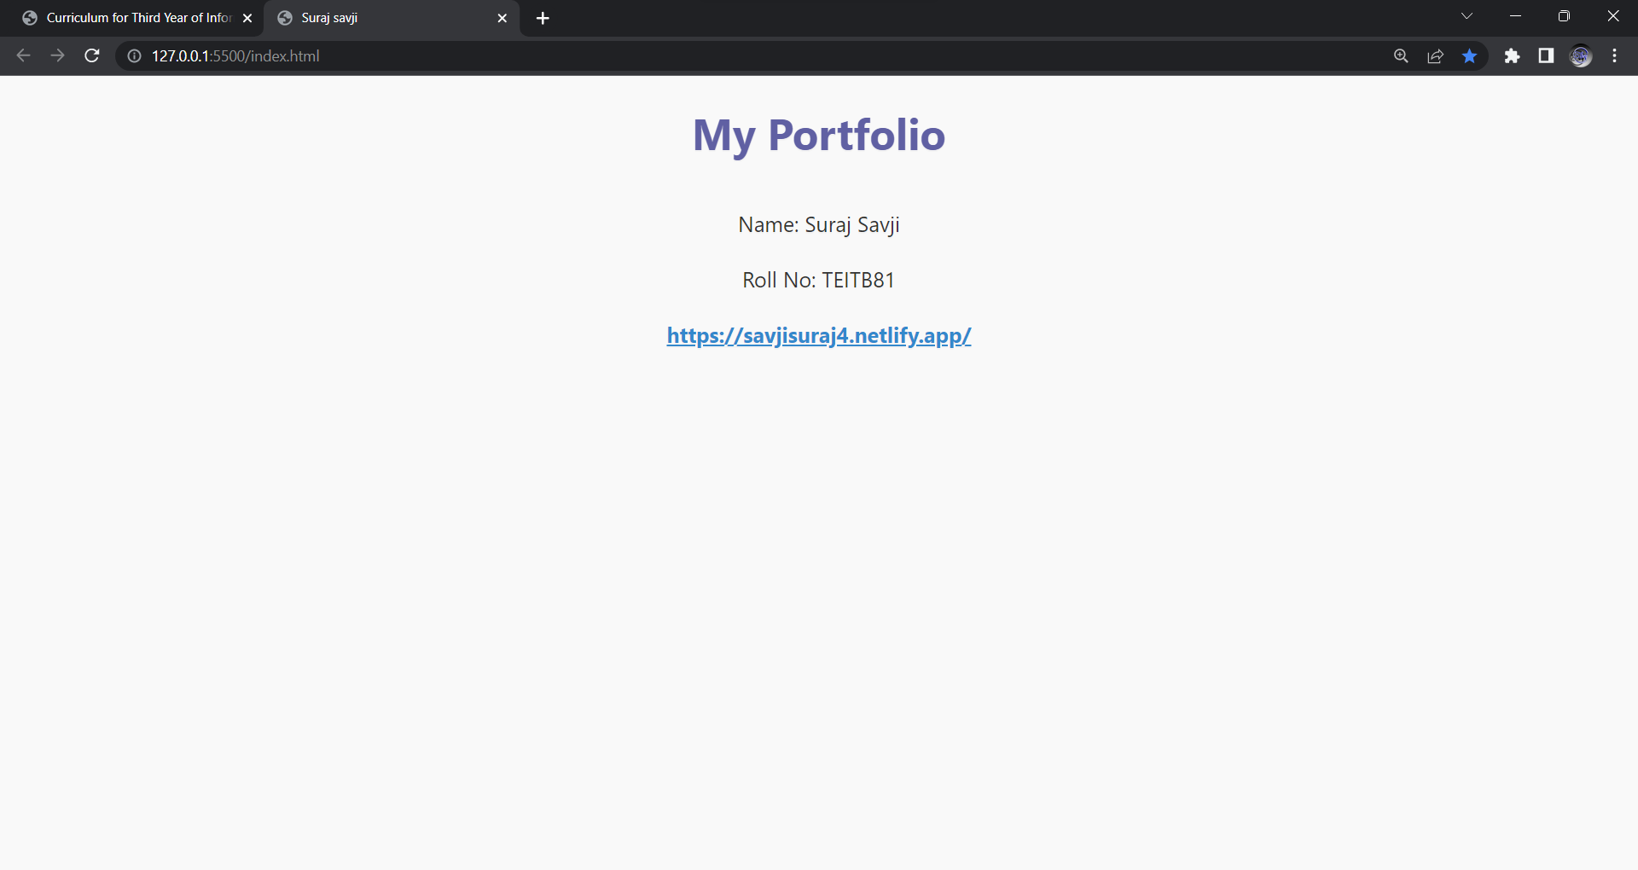

1. **Mobile View**

